1. Physical -  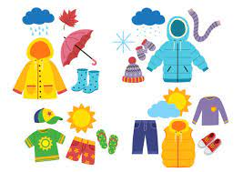   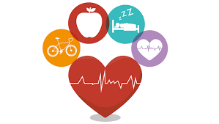
2. Safety - 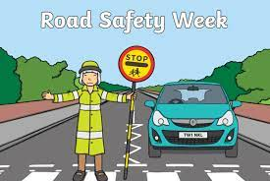 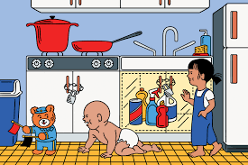 
3. Emotional - 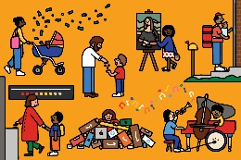

4. Development - 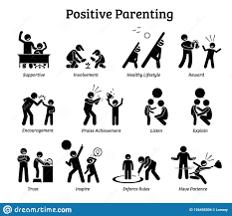  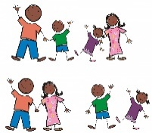

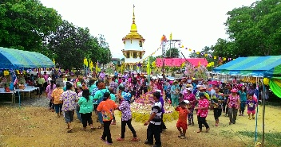

[This Photo](https://commons.wikimedia.org/wiki/File:Buddhist_festivals,Songkran_Festival_Day.jpg) by Unknown Author is licensed under [CC BY-SA](https://creativecommons.org/licenses/by-sa/3.0/)



[This Photo](https://www.colegiomanuelrodriguez.cl/mr/exelearning/5IngU2/previous_knowledge.html) by Unknown Author is licensed under [CC BY-SA](https://creativecommons.org/licenses/by-sa/3.0/)