Coronavirus - Safeguarding Children & Adults:
Information and Updates

During the current Coronavirus outbreak we still need to help keep children and adults at risk safe from abuse and neglect and share up to date information with the public and professionals. The threat the country is facing from COVID-19 is evolving by the day and is placing the residents of Brighton and Hove in a position of real vulnerability. We are seeing many examples of positive action from communities, with offers of help and support from networks of volunteers and agencies across the public and private sectors.
At the same time a picture is emerging of a number of safeguarding issues and areas of exploitation that are a direct result of the pandemic. A significant concern of the Brighton and Hove Safeguarding Children Partnership (BHSCP) and the Brighton and Hove Safeguarding Adults Board (B&HSAB) is that much of this abuse may be hidden, particularly with people living in isolation, perhaps with perpetrators of abuse, and with the additional current issue that professionals are not able to visit clients as frequently.
We ask everyone – the public, volunteers and professionals from all sectors – to be particularly vigilant in identifying and reporting any concerns if you feel that a child or adult is at risk or is experiencing abuse or neglect. If you have a safeguarding concern about a child, please contact Front Door For Families or any concerns about an adult, please contact Health and Adult Social Care.
The BHSCP and B&HSAB would like to thank all our partner agencies for their hard and dedicated work in the current challenging circumstances.

Update from Brighton & Hove City Council’s Children’s Services
- Social workers and other practitioners within Safeguarding & Care provide essential services to children and families in the city. We want to keep supporting families during the current coronavirus situation at the same time as minimising the risk to our staff and our community due to the virus outbreak.

- Key safeguarding functions will continue during this period, including for example multi-agency Strategy Meetings, Initial Child Protection Conferences. Children’s Services will operate in accordance with government Covid-19 guidance on vulnerable children and young people.

- If you are concerned about the welfare of a child or have a safeguarding concern, please contact or Front Door for Families for advice:

Phone: 01273 290400
Out-of-hours: 01273 335905 (Emergency Duty Service).

Please leave a voicemail and a member of staff will get back to you.

Update from Sussex Police
Functions continue to operate as normal although much of the business has moved to the virtual space where appropriate and possible.
As a general note, police are responding to the new legislation with regards to reducing social gatherings and movement, our approach is based on 4 E’s – engage, explain, encourage and as a last resort enforcement.
• Police continue to respond to public protection calls
• Strategy meetings continue to be prioritised
• The police are maintaining their role in MASH, although triage may become more difficult if staff levels reduce
• Daily and weekly meetings continue to address risks in relation to Child Exploitation.

Update from Health
At this stage services across the system are operating as normal. Clinical practitioners across the health services may be redeployed to frontline health care facilities to meet the demand of increased pressure on hospitals. This may include paediatricians who may be asked to support clinical work with adults.
- The CCG is co-ordinating weekly system calls across all health providers, named and designated professional to discuss all issue relating to safeguarding children, and escalate concerns and mitigate risks.
- In addition, there is a weekly system call specifically in relation to Looked After Children, to discuss risks and actions
- Safeguarding medicals (CP medicals) may need to occur at venues other than hospitals due to capacity issues:
  - Paediatricians must be invited to all strategy discussions involving suspected NAI or CSA. They will help guide decision making around the need and timing of CP medicals.
  - Paediatricians will prioritise infants and high-risk cases, at the strategy discussion.
- GP’s are continuing to provide primary care health input as needed within the guidance from Public Health England
- Primary Care settings, CCG staff and all providers are being provided with resource packs to help empower staff to work with increased rates of Domestic Abuse, including a direct link into a dedicated resource within the CCG safeguarding team.
- All national guidance that is produced by Public Health England, NHS England or other relevant health organisations, is being analysed and reviewed in terms of its relevance to safeguarding, and how this may affect local delivery.

Covid-19: Issues to be aware of:

Protect yourself from Coronavirus fraud
National Trading Standards and Friends Against Scams are warning people to remain vigilant following a rise in coronavirus-related scams that seek to benefit from the public’s concern and uncertainty over COVID-19.
To protect yourself and your family please protect yourself and don't let fraudsters try to lure you in with offers that look too good to be true. The advice is simple, think very carefully before you hand over your money, and don’t give out your personal details unless you are sure who you are dealing with. Communities are also being urged to look out for signs of neighbours being targeted by doorstep criminals.
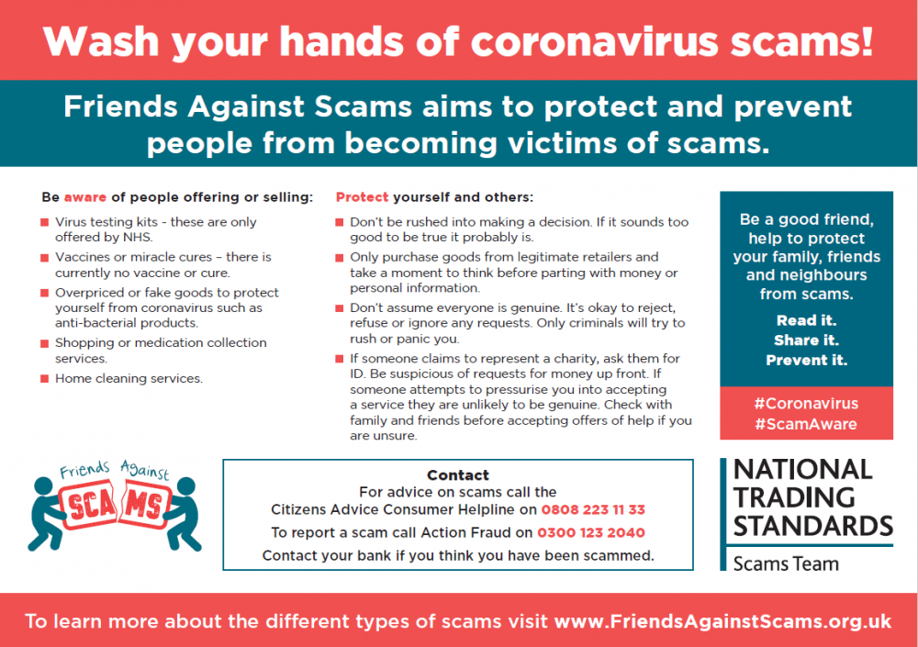

Coronavirus and Domestic Abuse
Whilst the Coronavirus situation is a worrying time for us all, this is particularly the case for adults and children living with domestic violence, in terms of escalating risks of abuse and serious harm and the feeling that they are trapped. The guidance below is designed to help in providing advice and support to keep safe as well as phone lines you can call if you are worried. Don’t forget that, if you or someone you live with has been, or you think might be harmed, call the police on 101 or in an emergency 999.
It is also important to consider unpaid carers in the context of domestic violence and abuse, in terms of the potential additional tensions that may arise in caring situations. Whilst it might not be possible to access respite, it is vital that carers and cared-for alike – where they can – use other means such as telephone calls, Facetime etc to connect with others. You are not alone and the services that are here to help are still here, even if the way they provide that support may be different from normal. Carers UK have information and guidance specifically developed for carers in response to queries about coronavirus.
It is important to know that you are not alone. Even if you are unable to leave your home at the moment, you can still access support in a number of ways:
- Information about support for those experiencing domestic violence and abuse in Brighton & Hove is available on the RISE website.
- Safelives have produced a guide for staying safe during COVID-19 for victims and survivors.
- Surviving Economic Abuse have produced guidance on economic abuse while self-isolating, as well as practical issues including benefits and sick pay.
- The Government has published COVID-19 guidance for domestic abuse safe accommodation provision.

Social Distancing and Isolation for Older People
As Coronavirus spreads across the UK it will be harder for older people to maintain social connections. Useful advice has been provided by the Campaign to End Loneliness.
_________________________________________________________________________
Information for the public and professionals:
Brighton & Hove City Council Coronavirus Support
As the situation with COVID-19 develops, Brighton and Hove City Council is working with partners in the NHS, Public Health England and other services to keep vital services running and providing the support everyone needs, especially to the most vulnerable. In response to this unprecedented situation, and in line with Government guidance, safeguarding and protecting the most vulnerable adults in our community remains a priority.
Brighton & Hove COVID-19 will be kept updated with the latest links and advice for residents and businesses in the county.
Information from the Council for supporting your wellbeing.

NHS Advice
The NHS have produced a range of advice, including symptoms, what to do if you think you have Coronavirus, and self-isolation.
It’s particularly important to take care of your mental health whilst self-isolating. For tips on how to keep on top of your mental wellbeing and cope with how you may feel while staying at home, visit Every Mind Matters.

_____________________________________________________________________________
Government Advice
The Coronavirus page on the GOV.UK website has provides guidance on a range of issues, including advice for those working in healthcare settings, residential care homes, supported living and home care settings.
GOV.UK Coronavirus Information Service WhatsApp
This new free service aims to provide official, trustworthy and timely information advice about Coronavirus, and will further reduce the burden on NHS Services. To use the free service, simply add 07860 064 422 into your phone contacts and message the word ‘hi’ in a WhatsApp message to get started.

Covid-19 Symptom Tracker
An app has been developed by Guys and St Thomas’ and Kings College NHS Trusts to help the spread of COVID-19. Please download the COVID Symptom Tracker app to support this valuable research.

Social Care Institute of Excellence (SCIE)
SCIE are regularly updating their COVID-19 Hub to provide advice to local authorities and care providers.
_____________________________________________________________________________
How to help your neighbours
Looking for a way to help people in your local community right now?
The British Red Cross says that little acts of kindness are important, now more than ever, and really do go a long way in times of crisis.
- Keep in touch regularly with family, friends and neighbours – a quick chat on the phone or a message on social media will raise their spirits and yours.
- If you can, be the eyes and ears of your community (but keep that social distance!) by checking on people who may be vulnerable or isolated and finding out what they might need – can you pick up shopping or medicines safely and leave them where they can access them?
- No one needs trolley loads of toilet roll! Only buy what you need so that there is enough for everyone, especially for those who can’t afford to buy ahead.
- Do look after yourself – eating, sleeping and exercising safely (even indoors) will help keep you well and more able to support others.

Brighton and Hove City Council website also offers advice on how to support your neighbours how to find out more information about your neighbourhood.

Legal Updates:

Coronavirus Act 2020
The Coronavirus Act received royal assent on 25 March 2020. The proposals set out in the Act will significantly enhance the ability of public bodies across the UK to provide an effective response to tackle this epidemic by introducing temporary legislation and regulatory easing.
The legislation will be time-limited – for 2 years – and not all of the measures will come into force immediately.
The easing includes:
- NHS Continuing Healthcare (CHC) Assessments
Provision to allow NHS Providers to delay undertaking the assessment process for NHS CHC assessments until after the coronavirus outbreak has ended.

- Temporary amendments to the Mental Health Act 1983
Allowing a single approved practitioner or a single medical practitioner to undertake certain functions and extension of time limits relating to detention and transfer of patients.

- NHS and Local Authority (LA) care and support
Covers three provisions during the Coronavirus pandemic:
- Provision that a LA may lawfully prioritise who and what type of needs it will meet, rather than being required to meet all eligible assessed needs as specified under the Care Act 2014.
- Provision that LA’s may lawfully determine whether and the extent to which it will carry out assessments in individual’s needs and review care plans, or carry out financial assessments, rather than being required to carry these out in all cases as is currently set out in the Care Act.
- Provision for the Secretary of State for Health and Social Care to direct LA’s in relation to the prioritisation of services to meet care and support needs in accordance with guidance issued by the Department of Health and Social Care.
_________________________________________________________________________
Resources:
Advice Poster
Advice poster for adults who are self-isolating

Easy Reads
GOV.UK stay at home guidance
Mencap guide on Coronavirus
Coronavirus and health issues
How to stay safe
What to do if you get ill

Further Resources
COVID-19 advice for patients translated into multiple languages
Summary of key guidance in sign language
The Children’s Commissioner has issued Covid-19 advice for children
The NSPCC have provided Covid-19 advice and support for parents and care givers
_________________________________________________________________________
Safeguarding children and adults through the Coronavirus epidemic: What do volunteers need to know to keep themselves and others safe?
With the Coronavirus outbreak community groups and volunteers are increasingly crucial in supporting adults at risk. With that in mind, you are volunteering with your local community, or you are hiring volunteers, it is important that you safeguard yourself and others from harm and abuse.
The Ann Craft Trust has published information to help.
The Government has produced a factsheet designed to address specific concerns that people involved in supporting their community may have at this time.
_________________________________________________________________________
Training
Health Education England has made available free online safeguarding adults training.

