SLOWER IS SAFER
The faster we drive, the greater our risk of crashing,and the harder we hit if we crash.
A crash at 30mph has twice the energy and destructive potential of a crash at 20mph.

SHORTER STOPPING DISTANCES
The faster a vehicle is travelling,
the longer it takes to stop. At higher speeds, a driver has less time to react and stop in time in an emergency.

LIMITS NOT TARGETS
The speed limit is the top speed for any particular road, but it is often safer to travel at much lower speeds, especially in places where people walk and cycle.

VEHICLE
SAFE SPEEDS
ROAD DESIGN
Traffic lights, roundabouts, speed bumps and rumble strips help slow traffic down.

Why do we need safe speeds?

Safe speeds reduce the risk of road death and injury and enable more people to make safe and healthy journeys on foot and by bike

TECHNOLOGY
Intelligent speed assistance (ISA) helps drivers keep within speed limits.
Speed is a factor in many crashes and effective speed management is a crucial part of the safe systems approach to road safety – a shared approach to prevent death and serious injury from road crashes.

SPEEDING DRIVERS SHOULD EXPECT TO BE CAUGHT
We need comprehensive speed
enforcement and investment in roads policing to catch speeding drivers and deter people from speeding.

RURAL ROADS ARE NOT RACETRACKS
Narrow, bendy roads
often lack pavements or cycle paths and are unsuited to high speeds.

HAPPY, HEALTHY COMMUNITIES
Where traffic is slow,
more people choose to walk or cycle. 20mph is an appropriate maximum speed in places where people live.

Safe speeds save lives
We might say it’s ok to speed because everyone else is doing it. But if we all drive too fast, we collectively increase the risk of crashes on our roads, and we
increase the risk of someone that we love being involved in a crash.
Shout out for safe speeds and safe streets where you live. Find out more at brake.org.uk.

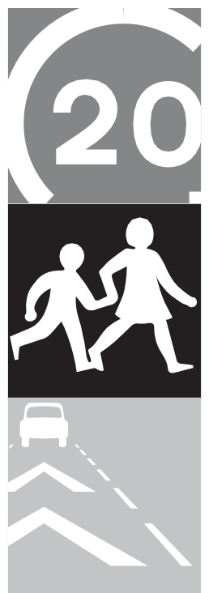

Coordinated by Sponsored by Supporting #RoadSafetyWeek
@brakecharity brake.org.uk
© Brake 2020

