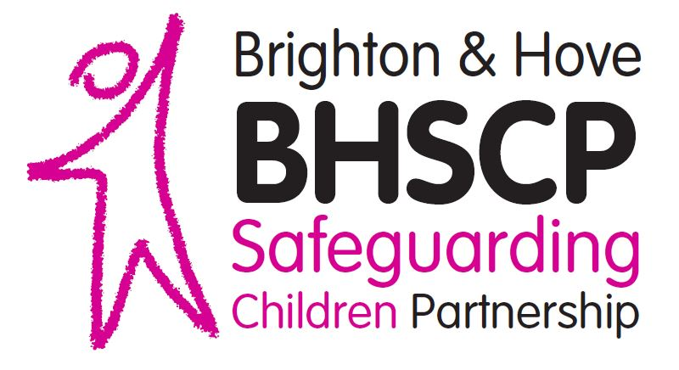

Brighton & Hove Safeguarding Children Partnership

Lay Member Expression of Interest

Name
Contact address
Contact email address
Contact telephone number

Please explain why you are applying to be a lay member of the Brighton & Hove Safeguarding Children Partnership (200 words).
Referring to the person specification, please let us know how you meet the criteria for becoming a lay member, including examples from your experience (500 – 1000 words).
Lay members must be independent of local agencies and organisations. Therefore, please declare below if you have been an employee of any agency represented on the Partnership within the last two years, or if you are related to, or residing with, an employee of any agency represented on the Partnership.

The Brighton & Hove Safeguarding Children Partnership, is sponsored by Brighton and Hove City Council (BHCC), and as such respects your privacy and is committed to protecting your personal data. BHCC comply with the Data Protection Act, any subsequent replacement legislation and the General Data Protection Regulation (EU) 2016/679 (GDPR). For further information on how your information is used and your rights please go to the Brighton & Hove Website https://www.brighton-hove.gov.uk/content/about-website/service-privacy-notices/customer-satisfaction-surveys-privacy-notice.

The information that you provide may be used by the City Council for business purposes including the prevention and detection of fraud as well as for HR purposes and administration. If you are appointed, this information will form part of your personnel record and will be treated as confidential and will not be disclosed to any unauthorised person.
Please tick to confirm that you consent to the use of your personal data, as outlined above. | ☐

Once completed, please send this form to BHSCP@Brighton-hove.gov.uk, or alternatively by post to:
Safeguarding Children Partnership, Moulsecoomb Hub North, Hodshrove Lane, Brighton, BN2 4SE

Please return your application to us by 31st May 2021

