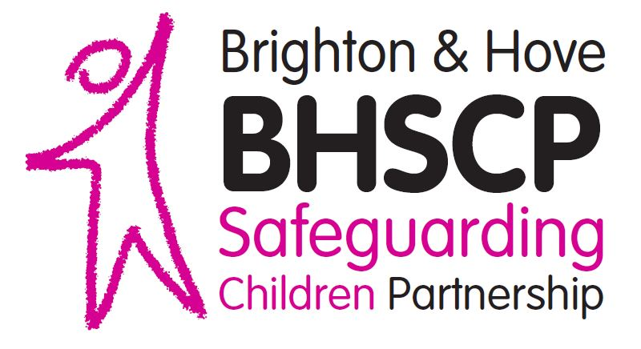

Brighton & Hove Safeguarding Children Partnership

Lay Member Role Description and Person Specification

About the Safeguarding Children Partnership

The Brighton & Hove Safeguarding Children Partnership (BHSCP) is comprised of agencies and organisations who work together across the city to keep children and young people safe and promote their emotional health and wellbeing.
The BHSCP is led by three lead agencies who collectively hold statutory responsibility for keeping children and young people safe and promoting their welfare; The three ‘lead partners’ are the Local Authority (via Families, Children and Learning), Health (via Brighton & Hove Clinical Commissioning Group) and Sussex Police.
We have a vision that children and young people in Brighton & Hove live a life free from fear, harm, abuse, and exploitation, enabling every child in every part of the City to achieve their potential. This is underpinned by our Core Values:
• A child centred approach: for services to be effective they should be based on a clear understanding of the needs and views of children.
• Safeguarding is everyone’s responsibility: for services to be effective each citizen, practitioner and organisation should play their part

The BHSCP’s objectives are to:
- Co-ordinate local work undertaken by all agencies and individuals to safeguard and promote the welfare of children and young people
- Ensure the effectiveness of that work
The three lead partners meet quarterly for the BHSCP Steering Group. Its purpose is to set and drive the delivery of the BHSCP business plan. The Steering Group also plays a key role in overseeing the progress against the work plans of each subgroup to ensure consistency and a joined-up approach across the BHSCP.
The BHSCP Partnership Board brings together the wider partners to work to the strategic aims set out by the Steering Group.

Please see BHSCP Structure chart in Appendix 1

1. The Role of the Lay Member

We are looking to recruit lay members to attend Partnership meetings, contribute to discussions and decision-making, and make links between the BHSCP and the local community. Successful applicants will offer challenge and scrutiny to the BHSCP, particularly around public awareness and engagement helping us as a partnership to understand the concerns of families of Brighton & Hove with safeguarding and support needs.

2. The Job Description

The role requires the volunteer lay member to:
- Attend BHSCP Partnership Board meetings, contributing to agreements and participate in any working groups as appropriate;
- Attend BHSCP subgroups, read papers and other relevant information and contribute from a lay persons’ perspective;
- Provide an extra level of scrutiny and challenge to our work in an open and constructive way;
- Encourage professionals to speak in a way that is easier to understand, eliminating jargon;
- Bring in a valuable local representative voice into our decision making, challenge the BHSCP on the accessibility of policies and procedures by our families and;
- Actively support stronger community engagement and understanding of local child safeguarding issues and contribute to an improved understanding of child safeguarding work in the wider community.

3. Person specification

Lay members must:
- Be residents of Brighton & Hove and not a current service user of Child Safeguarding Services commissioned within Brighton & Hove;
- Have good knowledge of the community and social welfare issues as they relate to families or children; including the community, voluntary sector or other groups within Brighton & Hove;
- Declare any prior connection with agencies or elected members working with children and families within Brighton & Hove; this includes both lay members and their family members;
- Be able to communicate effectively within meetings and have the confidence to ask questions and challenge people in a constructive way;
- Have a commitment to improving outcomes for children and their families as well as keeping children and young people safe;
- Have a commitment to understanding and applying statutory guidance such as the Working Together to Safeguard Children 2018 ;
- Have a commitment to equality and diversity and in promoting good outcomes for families and children in Brighton & Hove;
- Be able and willing to maintain independence and provide constructive challenge from a community perspective and;
- Demonstrate an understanding of the handling of sensitive and confidential data.
Lay members should:
- Ideally have membership experience of an organisation or Board and;
- Have good knowledge or experience of the statutory and voluntary services provided to children.

4. Recruitment and Selection
Lay members will be appointed following an interview process and subject to statutory checks and references. One personal and one professional reference will be requested.
Applicants will be required to disclose any previous personal involvement in child protection processes, although it should be noted that this would not constitute a barrier to appointment.
Successful applicants will be asked to sign a ‘Lay Members’ Agreement’ before taking up the role, a copy of which can be provided upon request.

5. Our Commitment to you
Lay members will be supported with an induction programme to assist them in taking on the role, including:
- A basic briefing on the function of the Safeguarding Children Partnership and the duties of its members; this will include receiving a copy of the BHSCP annual report and business plan;
- A meeting with the BHSCP Chair and Business Manager and other relevant staff;
- Identification of further training and learning needs.
Lay members will be expected to attend mandatory Safeguarding Children training or complete the BHSCP E-learning course relating to children safeguarding within the first three months of appointment.
A ‘buddying’ arrangement will be in place for each lay member. Buddies will meet with lay members before and after Partnership Board meetings and any necessary Subgroups to support with any questions or issues they may have, helping them to get the best out of their experience and to fully participate.
Lay members will also benefit from regular contact meetings with the BHSCP Business Manager, to support their understanding of BHSCP work. .

6. Expenses
The role is a voluntary one with lay members receiving travel expenses and associated expenses (up to £50 per meeting attended).
Attendance at Working Groups (Task and Finish Groups) and conferences is optional and therefore expenses will not normally be paid.

7. Appointment and notice period
The appointment is for a two-year period with an annual review. The appointment can be terminated at any time with an expectation of one month’s notice period on either side.

8. How to apply
If you wish to discuss this role further, please contact the BHSCP Business Manager at BHSCP@brighton-hove.gov.uk or 01273 292379.
To apply for this role, please complete the expression of interest form, and send to BHSCP@brighton-hove.gov.uk

Appendix 1
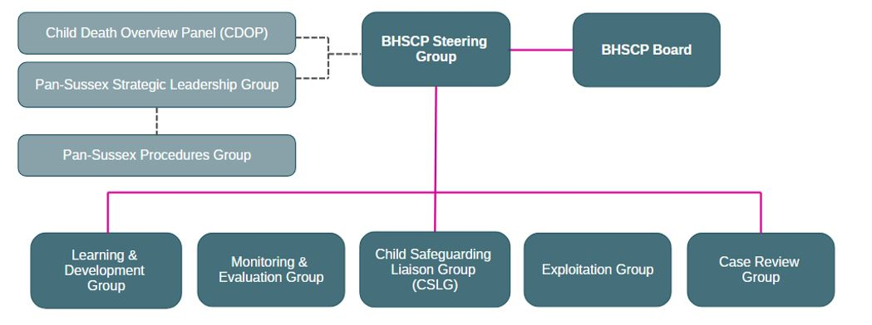
BHSCP Structure (subject to amendment in September 2020):

https://assets.publishing.service.gov.uk/government/uploads/system/uploads/attachment_data/file/779401/Working_Together_to_Safeguard-Children.pdf

