Brighton & Hove Safeguarding Children Partnership
Quality Assurance Framework April 2020 – March 2023
Introduction
The purpose of this document is to set out the activities undertaken by the Brighton & Hove Safeguarding Children Partnership (BHSCP) and by individual agencies which contribute to service development and continuous learning and improvement.

The Quality Assurance Framework outputs provide the Partnership with an overall picture of how effective the BHSCP is in keeping children safe and promoting their wellbeing.

This work is key to our partners gaining an understanding of:
- How effective the BHSCP’s arrangements are at keeping children and young people safe across the city
- How best to identify and replicate best practice
- The methods we use to identify and address areas for improvement
- Where to deploy resources and inform our business plan priorities
- The lived experience of children and young people in receipt of services. This means that the BHSCP ensures that children and young people are at the centre of decision making at both an individual level and also when developing and designing child safeguarding services across the partnership.
1. The BHSCP’s vision, values and governance arrangements
1.1 The BHSCP’s vision and values are at the heart of this framework.
The BHSCP vision: “Children and young people in Brighton & Hove live a life free from fear, harm, abuse and exploitation, enabling every child in every part of the City to achieve their potential.”
The BHSCP’s vision is underpinned by its core values:
- A child centred approach: for services to be effective they should be based on a clear understanding of the needs and views of children.

- Safeguarding is everyone’s responsibility: for services to be effective each citizen, practitioner and organisation should play their part.
1.2 BHSCP: published safeguarding arrangements
In June 2019 the Brighton & Hove Safeguarding Children Partnership (BHSCP) published its arrangements to safeguard children across the city. This included a set of guiding principles including:
“Striving to constantly improve and develop the quality of safeguarding across the city” and
“development of an effective form of independent scrutiny”.
1.3 Working Together to Safeguard Children 2018 describes the role of independent scrutiny:
“…to provide assurance in judging the effectiveness of multi-agency arrangements to safeguard and promote the welfare of all children in a local area, including arrangements to identify and review serious child safeguarding cases. This independent scrutiny will be part of a wider system which includes the independent inspectorates’ single assessment of the individual safeguarding partners and the Joint Targeted Area Inspections”.

1.4 The BHSCP’s Monitoring & Evaluation Subgroup coordinates quality assurance work on behalf of the Partnership. Key functions include the analysis of performance data and reports, alongside workforce development and summary audit reports with an emphasis on analysis, findings, action and learning, with the ability to drill down into services or themes but there also needs to be a “golden thread” running through the BHSCP’s multi-agency work.

2. BHSCP Quality Assurance: key indicators/sources of information
- Performance Data | - Feedback from Children and their families.
- Audits – single and multi-agency

- Lay members | - Feedback from practitioners
- Independent scrutineer: challenge and reflection | - BHSCP annual report
- Complaints and compliments | - Peer reviews
- Independent Chair of Monitoring & Evaluation sub-group | - Learning from local, regional and national child safeguarding practice reviews
- Independent monitoring and inspections | - Single agency reports

In addition, where feasible, Quality Assurance work such as audit themes will be undertaken pan Sussex. This will provide both a broader picture, greater consistency across Sussex and promote resource efficiency. Decisions regarding such initiatives will be determined by the Pan Sussex Strategic Leaders.

3. BHSCP Business Plan Priorities
Our quality assurance work also links to our business plan priorities detailed below, to enable us to track progress made in these priority work areas. The current BHSCP business plan runs from April 2020 to March 2023 and has 4 areas of focus:
Priority 1: Partnership Engagement and Accountability: agency lead: Brighton & Hove City Council

Priority 2: Safeguarding children from violence and exploitation: agency lead: Sussex Police

Priority 3: Reducing Neglect: agency lead: Brighton & Hove City Council
Priority 4: Mental Health and Emotional Health and Wellbeing: agency lead: Brighton & Hove City Clinical Commissioning Group

4. Quality Assurance Framework - key elements
4.1 The role of the Independent Scrutineer and lay members: The three safeguarding lead partners must ensure there is independent scrutiny of the effectiveness of the BHSCP arrangements.
Working Together to Safeguard Children 2018 stipulates that:
“The independent scrutineer should consider how effectively the arrangements are working for children and families, as well as for practitioners, and how well the safeguarding partners are providing strong leadership and agree with the safeguarding partners how this will be reported.”
Key elements of the independent scrutineer’s role include giving constructive feedback to the lead partners about whether the partnership’s arrangements are having a positive impact on front line practice; what is going well and what needs to improve. Another strand of the scrutineer’s role is to consider how well agencies and organisations work together to safeguard and promote the welfare of children and to hold each other to account for effective safeguarding. The BHSCP currently has two independent scrutineers – one of whom chairs the Monitoring & Evaluation Group in order to provide constructive challenge to help the group develop robust quality standards.
As local residents, our lay members bring their individual experiences of living in the Brighton & Hove community to this role. In addition to their local knowledge and experience lay members have a scrutiny function and their absolute independence enables them to provide constructive challenge to the partnership.

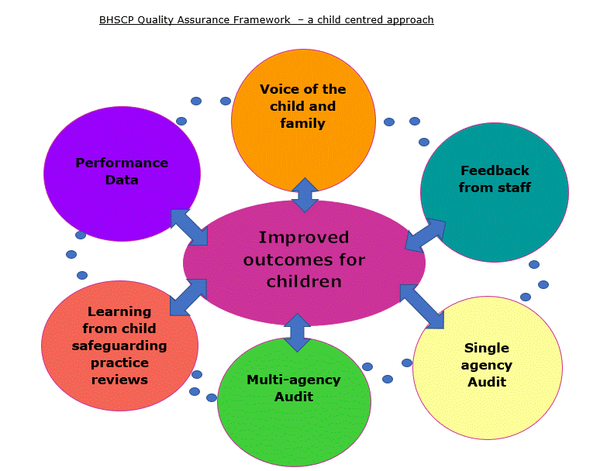

4.2 The Voice of the Child and Family We will seek out the voice of the child and their family through an understanding of their specific needs including children who are at risk of abuse or who have individual needs or where they are living in homes in which family members reside who have complex or challenging needs to address. This includes participation activities that enable partner agencies and organisations to understand how their services and interventions are experienced by children and families. This insight will be used to develop and improve services and practice to make a positive difference to children, young people and their families. Families who are the subjects of learning reviews will also be encouraged to participate in learning review activity to help professionals to understand how the family felt about the services provided to them and feedback about how to improve outcomes for family by building on strengths and developing practice where required. We will also look for the voice of the child and family in our audit work.
4.3. Engaging with front line staff and our community groups is also important and this is achieved using a variety of methods including briefings to staff, involvement of front line practitioners and managers in learning reviews (see below); participation in BHSCP audits; via discussions at the Child Safeguarding Liaison Meetings; and staff surveys.
4.4. Child Safeguarding Practices Reviews (CSPRs) and other learning reviews, including local, regional and national learning, analyse what happened and why following a serious child safeguarding incident and identify learning to improve future practice standards. The BHSCP is responsible for ensuring that learning from CSPRs, as well as relevant reviews across Sussex and national learning are shared and acted upon. The Case Review Group (CRG) makes sure that cases meeting threshold for a local review will be commissioned and that staff involved are able and given the time, support and space to enable them to attend, thus contributing to and enriching the learning process. The CRG’s learning from a strengths-based stance, promotes building on practice strengths and opportunities whilst addressing areas requiring improvement. The CRG is committed to sharing learning in an appropriate and transparent way with children, and their families; practitioners and their managers; and the wider partnership in the local authority area and beyond.
4.5 Multi-agency and single agency audits provide an opportunity for staff and managers to use audit activity to encourage a reflective environment which in turn supports organisational and partnership learning. The BHSCP uses audits to identify the quality of practice and lessons to be learned in terms of both multi-agency, single agency and multi-disciplinary practice Two deep dive BHSCP audits are delivered per annum and a local Sussex s11 audit every two years.
4.6 BHSCP Data set - this key performance measure is undergoing development. Data should not be viewed as a straightforward measure of good or bad practice but interrogated to see what lies behind it. The BHSCP uses a range of data from across multi-agency safeguarding systems to triangulate with other evidence and information to understand potential safeguarding implications. BHSCP data set analysis combined with qualitative feedback for example from written records, observation of practice and feedback from children, families and young people and practitioners develops a clearer picture of what is happening with regard to front line practice. This approach will help the BHSCP to develop and test hypotheses around the quality of child safeguarding practice across the city.
4.7 The BHSCP’s Learning and Development offer is linked directly to and informed by quality assurance work. The BHSCP Learning and Development offer is scoped by partner agencies who review and enhance the multi-agency training offer in light of findings from sources including audits; learning from both local, regional and national reviews; and business plan priority work.

5. Identification of risks and priority work
Developing a hypothesis: A key element of the partnership’s approach is to analyse sources of information (see diagram below) in order to identify potential issues, enabling a timely and informed understanding of potential risks.
This work supports a strengths-based approach in which the BHSCP objective is to continuously improve outcomes for children, young people and their families via service delivery enhancements across our partner agencies and organisations.

Hypothesis/es may be generated from data or audit or the voice of the child
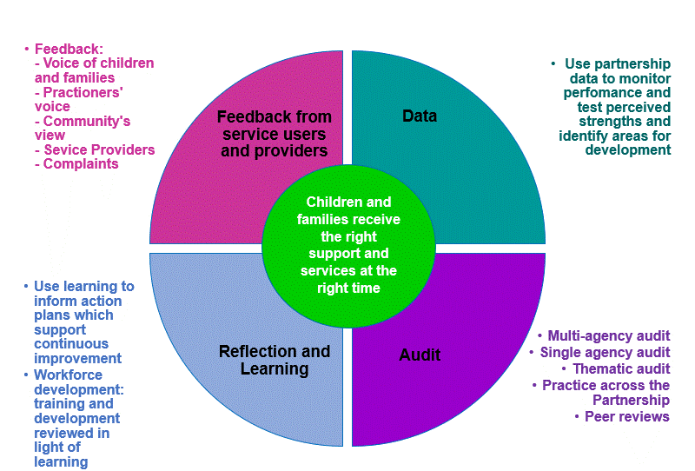

Appendix A
Brighton & Hove Safeguarding Children Partnership:
Structure of subgroups and key strategic partners

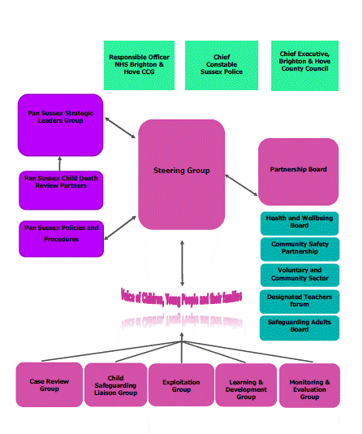

Section 11 of the Children Act 2004 - Places duties on a range of organisations, agencies and individuals to ensure their functions, and any services that they contract out to others, are discharged having regard to the need to safeguard and promote the welfare of children.

